Special Thanks To:

College of Education


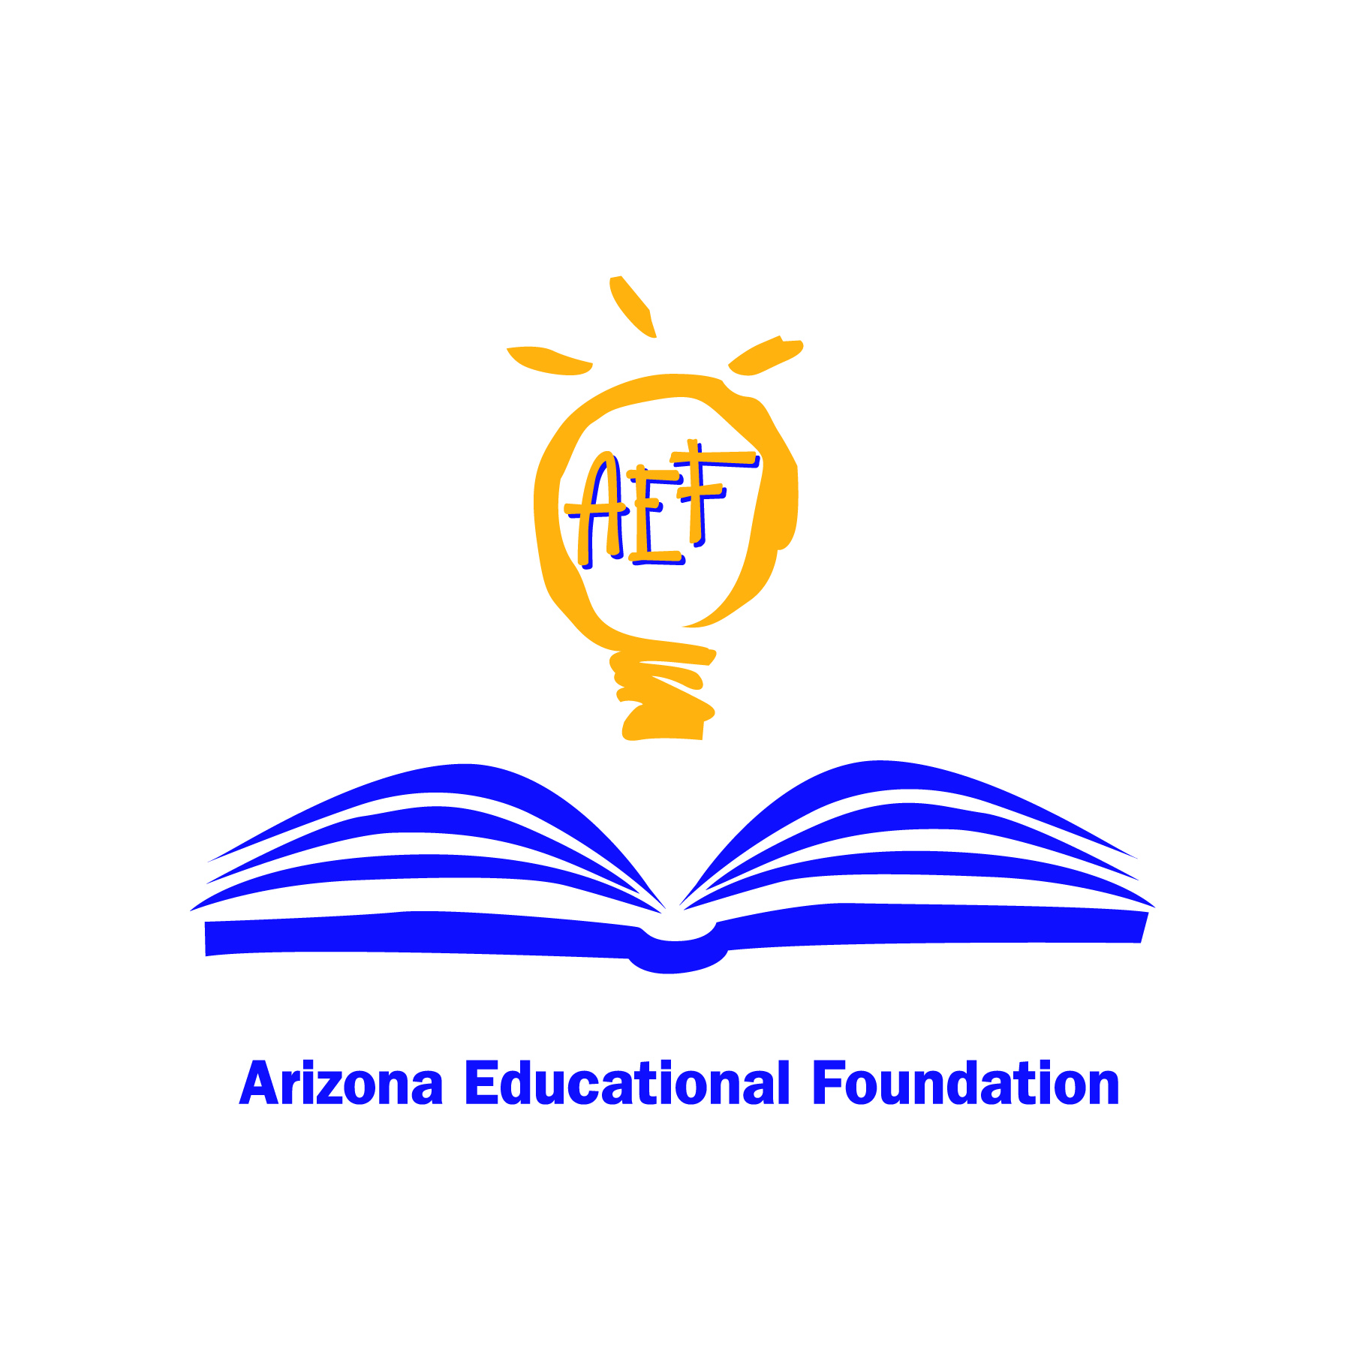

For more information
or
to register for the conference
visit
www.coe.nau.edu
or call
928.523.8746

NORTHERN ARIZONA UNIVERSITY’S
COLLEGE OF EDUCATION
PROUDLY PRESENTS…

There’s A Reason I’m A Teacher Conference


Tuesday, April 6, 2010

Featuring:
Anthony Mullen
2009 National Teacher of the Year
&
Joy Weiss
2010 Arizona Teacher of the Year

7:45 a.m. – 2:35 p.m.
College of Education & Ashurst Auditorium
Conference Agenda

7:45-8:00 - Meet in Ashurst Auditorium
8:00-8:10 - Welcome from Dean Kain
8:10-8:25 - Craig Bowie and the Flagstaff Arts and Leadership Academy
(FALA) Drummers

8:25 - Introduction of Speakers and Program Events
8:30 - National Teacher of the Year
Featuring: Anthony Mullen
9:15-9:30 - Break & Refreshments
9:35 - Arizona Teacher of the Year
Featuring: Joy Weiss

10:00 - Registration and Distribution of Book Bags, COE Main Lobby

10:30-11:40 - Breakout Session I, COE rooms
11:50-1:00 - Breakout Session II, COE rooms

1:00–1:20 - Break
Refreshments will be provided in the COE upstairs lobby.

1:25-2:35 - Breakout Session III, COE rooms

Session Descriptions

10:30-11:40 Breakout Sessions I, College of Education

- Room 124 – Jamie Valderrama: Integrative Classroom Management at the Secondary Level
Integrative classroom management takes into account the relationship developed, relevancy introduced and rigor that accompanies whole student teaching. This session will provide you with the foundational tools of love, humor, respect and patience needed to successfully create a classroom that not only inspires you as the teacher, but empowers and motivates your students.
- Room 174 – Joy Weiss: The Successful Skillful Teacher-Effective Strategies and Methods to Teach English Language Learners
An overview of strategies and methods for effectively engaging students across the curriculum with a special focus on reaching the English language learner while meeting the needs of the students and state mandates.

Elie Gaines: Elie has served in the field of education for 27 years. She received a BA and MEd.from NAU and an MA from University of Missouri-Kansas City. She is currently the Principal at Black Mountain Elementary, an A+ and Excelling K-5 school in Cave Creek, AZ. A recipient of a Milken National Educator Award in 2004, she serves on various local, state, and national boards and committees in support of PS-20 education and education reform.

Donna Moore: Donna teaches P.E. to K-5th grade students at Julia Randall and Frontier Elementary Schools in Payson. Donna is a professional who exudes enthusiasm for teaching, her students and the importance of developing life-long fitness habits at an early age. Donna received her Bachelor’s degree in P.E. from ASU and an MEd in Educational Leadership from NAU. The Arizona Educational Foundation has selected Donna Moore as a 2010 Ambassador for Excellence.

Larry Johnson: Larry is an 8th and 9th grade social studies teacher who has a BA in Elementary Education and Secondary Education with a History major from ASU, and a Masters Degree in Elementary Ed. with a reading emphasis. He has 32 years of classroom experience. In 2005 he served as an Arizona Ambassador for Excellence in Education, and is a ten year faculty member for the Arizona Foundation for Resource Education.

Marco Ramirez: Marco is the principal of Pueblo Gardens K-8 school in the Tucson Unified School District.

Cynthia Rolewski: In her 28th year of teaching, Cindy teaches reading and technology at La Cima Middle School in Tucson and pre-service teachers at NAU and Pima College. Early in her career she realized that teachers have the unique ability to transform lives and she wanted to do that in the most positive way possible. She wants all of her students, those in middle school and college, to believe that they have the power to make a difference; she wants them to realize that through their education they have options and opportunities to make the world a more fair and just place.

Barb Tingle: Barb is a kindergarten teacher at Sahuarita Primary School who believes that classrooms should support curiosity, variety and enthusiasm to inspire a love for learning within the framework of a child-centered, nurturing, and fun environment. She has a Master's degree in Early Childhood Ed., a Reading Specialist endorsement and was selected as a 2010 Arizona Ambassador for Excellence. She has enjoyed the roles of mentor and cognitive coach while working with new teachers and student interns.

Jamie Valderrama: Jamie brings passion and enthusiasm along with knowledge and experience to learning. When entering her classroom, students are immediately drawn to her enthusiasm for learning. She is dedicated and cares deeply for each and every student. Jamie recognizes the importance of being a good role model and takes her responsibility seriously. Her teaching reaches beyond the classroom. By earning her students’ trust, she takes them on a journey of learning beyond the classroom to the real world in consideration of the impact they can make on the world.

11:50-1:00 Breakout Sessions II, College of Education

- Room 124 – Jamie Valderrama: Integrative Classroom Management at the Secondary Level
Integrative classroom management takes into account the relationship developed, relevancy introduced and rigor that accompanies whole student teaching. This session will provide you with the foundational tools of love, humor, respect and patience needed to successfully create a classroom that not only inspires you as the teacher, but empowers and motivates your students.
- Room 174 – Joy Weiss: The Successful Skillful Teacher-Effective strategies and Methods to teach English Language Learners
An overview of strategies and methods for effectively engaging students across the curriculum with a special focus on reaching the English language learner while meeting the needs of the students and state mandates.
- Room 185 - Cynthia Rolewski: Integrating Technology into Your Classroom
Participants in this hands-on session will learn how and why our traditional methods of delivery are no longer relevant and they will be introduced to a variety of engaging technology resources to use to better meet the needs of today's digital learners.
- Room 200 – Barb Tingle: Getting Students, Parents and Teachers Ready for the First Day of School
A positive, welcoming and fun first day can set the tone of a whole school year for students, parents and teachers. In this workshop you'll see and hear a variety of ways for teachers to get themselves, their classrooms, their class parents and students ready for the big event even before the first bell rings. Information and strategies will be geared towards the kindergarten level but could be used in the other primary grades.
- Room 201 – Larry Johnson: Putting the F Word (Fun) back into the three R’s of Education: Rigor, Relevancy and Relationships
Participants will learn how the core elements of teaching (Curriculum, Instruction, Classroom Management) are integrated with the new three R's of education (Rigor, Relevancy, Relationships) to create a positive classroom learning environment that is fun and motivating for students to want to learn in.
- Room 203 – Marco Ramirez: Teaching Mathematics Successfully
Participants will examine a mathematics lesson and reflect on what makes the lesson successful. Successful mathematics includes engagement, content, and intentionality.
- Room 204 –Elie Gaines: A Principal Shares Tips on Interviewing
What to wear? What to say? How to prepare? Not far from the classroom, in her 2nd year as school Principal Elie Gaines will share interviewing tips for teachers entering the field for the first time.
- Room 205 - Kimberly Allen: Student Engagement Strategies that are Rigorous and Relevant for Students at the Middle School Level
Using Daggett’s Model for Relevancy and Rigor, Instructional Scaffolding, and Marzano’s strategies, this session will focus on how middle school teachers can plan for academic rigor and use rigorous teaching to address the needs of all students.
- Room 211 – Donna Moore: Healthy Kids Learn Better Research now supports the vital role physical activity plays in the academic performance of children. This workshop will address the epidemic of childhood obesity and the impact EVERY teacher has in the development of the "Whole Healthy Child." By instilling heart-healthy lessons and the joy of movement at a very early age, we have the opportunity to reverse this devastating trend. Obesity not only affects children physically, but socially and psychologically. It takes a village to raise a child. Come learn how to become an active member in your village to begin reversing this epidemic taking over America's youth.

1:30-2:30 Breakout Sessions III, College of Education

- Room 124 – Jamie Valderrama: Integrative Classroom Management at the Secondary Level
Integrative classroom management takes into account the relationship developed, relevancy introduced and rigor that accompanies whole student teaching. This session will provide you with the foundational tools of love, humor, respect and patience needed to successfully create a classroom that not only inspires you as the teacher, but empowers and motivates your students.
- Room 174 – Joy Weiss: The Successful Skillful Teacher-Effective Strategies and Methods to Teach English Language Learners
An overview of strategies and methods for effectively engaging students across the curriculum with a special focus on reaching the English language learner while meeting the needs of the students and state mandates.
- Room 185 - Cynthia Rolewski: Integrating Technology into Your Classroom
Participants in this hands-on session will learn how and why our traditional methods of delivery are no longer relevant and they will be introduced to a variety of engaging technology resources to use to better meet the needs of today's digital learners.
- Room 200 – Barb Tingle: Getting Students, Parents and Teachers Ready for the First Day of School
A positive, welcoming and fun first day can set the tone of a whole school year for students, parents and teachers. In this workshop you'll see and hear a variety of ways for teachers to get themselves, their classrooms, their class parents and students ready for the big event even before the first bell rings. Information and strategies will be geared towards the kindergarten level but could be used in the other primary grades.
- Room 203 – Marco Ramirez: Teaching Mathematics Successfully
Participants will examine a mathematics lesson and reflect on what makes the lesson successful. Successful mathematics includes engagement, content, and intentionality.
- Room 204 – Elie Gaines: A Principal Shares Tips on Interviewing
What to wear? What to say? How to prepare? Not far from the classroom, in her 2nd year as school Principal Elie Gaines will share interviewing tips for teachers entering the field for the first time.

- Room 211 – Donna Moore: Teaching Social Skills for a Lifetime
Common social skills such as "Please" and "Thank You" have been lost in today's society. Believing in EVERY child and establishing high expectations creates an environment in which students exceed what they think is possible, at times conquering very real fears. EVERY child has the right to succeed and fail without fear of ridicule. Come learn how to empower students to take ownership of their behavior, creating a safe atmosphere for EVERY child to succeed and achieve. This session will introduce FUN active learning opportunities in which students are taught respect, kindness and caring toward their peers and teachers. Skills to last a lifetime!


Presenters

Anthony J. Mullen: 2009 National Teacher of the Year:
“A teacher can receive no greater reward than the knowledge that he or she helped recover a lost student.” This statement by Anthony Mullen comes from a lifetime of service in the public sector, first as a New York City police officer and then as a teacher and mentor to teenagers who truly need a second chance. He is a 9-12th grade special education teacher at The ARCH School, an alternative branch of Greenwich High School in Greenwich, Connecticut. Providing passion, professionalism and perseverance are the keys to his drive as a successful educator.

Joy Weiss: 2010 Arizona Teacher of the Year
JoyWeiss is a first grade ELD teacher at Balsz Elementary. She has taught for 11 years. She believes that the most important way to engage students is by making them active participants in the process of learning. Teaching is more than instructing, but empowering students to be lifelong learners.

Kimberly Allen: Kimberly currently serves as a School and District Facilitator with WestEd and is President of Cultural Perspectives, her educational consulting company. Ms. Allen's prior experiences include serving as Deputy Associate Superintendent of School Improvement and Intervention for the Arizona Department of Education, Principal of Andre Agassi College Prep Academy in Las Vegas and a recipient of the Milken Family Foundation National Educator Award. Kimberly received her Bachelor's degree in Elementary Education and Special Education from Emporia State University and a Master's degree in Educational Administration and Leadership from Arizona State University. She is a 2010 Teacher Ambassador for Arizona.

10:30-11:40 Breakout Sessions I, College of Education

- Room 185 - Cynthia Rolewski: Integrating Technology into Your Classroom
Participants in this hands-on session will learn how and why our traditional methods of delivery are no longer relevant and they will be introduced to a variety of engaging technology resources to use to better meet the needs of today's digital learners.
- Room 200 – Barb Tingle: Getting Students, Parents and Teachers Ready for the First Day of School
A positive, welcoming and fun first day can set the tone of a whole school year for students, parents and teachers. In this workshop you'll see and hear a variety of ways for teachers to get themselves, their classrooms, their class parents and students ready for the big event even before the first bell rings. Information and strategies will be geared towards the kindergarten level but could be used in the other primary grades.
- Room 201 – Larry Johnson: Putting the F Word (Fun) back into the three R’s of Education: Rigor, Relevancy and Relationships
Participants will learn how the core elements of teaching (Curriculum, Instruction, Classroom Management) are integrated with the new three R's of education (Rigor, Relevancy, Relationships) to create a positive classroom learning environment that is fun and motivating for students to want to learn in.
- Room 203 – Marco Ramirez: Teaching Mathematics Successfully
Participants will examine a mathematics lesson and reflect on what makes the lesson successful. Successful mathematics includes engagement, content, and intentionality.
- Room 204 – Elie Gaines: What is Core Knowledge? A Preschool-Grade 8 Curricular Reform Effort - Elie Gaines has taught in Core Knowledge classrooms for 12 years, served as a Core Knowledge Coordinator, and has been a National Consultant and Advocate for the Core Knowledge Foundation since 2001. She shares her expertise in this area to bring the Core Knowledge Curriculum to pre-service teachers.
- Room 205 - Kimberly Allen: Student Engagement Strategies that are Rigorous and Relevant for Students at the Middle School Level
Using Daggett’s Model for Relevancy and Rigor, Instructional Scaffolding, and Marzano’s strategies, this session will focus on how middle school teachers can plan for academic rigor and use rigorous teaching to address the needs of all students.
- Room 211 – Donna Moore: Healthy Kids Learn Better
Research now supports the vital role physical activity plays in the academic performance of children. This workshop will address the epidemic of childhood obesity and the impact EVERY teacher has in the development of the "Whole Healthy Child." By instilling heart-healthy lessons and the joy of movement at a very early age, we have the opportunity to reverse this devastating trend. Obesity not only affects children physically, but socially and psychologically. It takes a village to raise a child. Come learn how to become an active member in your village to begin reversing this epidemic taking over America's youth.

